Zambia

## GNI per capita and development level

The data set shows the GNI per capita and development level of the country each year.

## # A tibble: 19 x 5  
## country iso3c date GNIperCapita devCategory   
## <chr> <chr> <dbl> <dbl> <chr>   
## 1 Zambia ZMB 1996 1125. Lower Middle Income  
## 2 Zambia ZMB 1998 1016. Low Income   
## 3 Zambia ZMB 2000 1079. Lower Middle Income  
## 4 Zambia ZMB 2002 982. Low Income   
## 5 Zambia ZMB 2003 569. Low Income   
## 6 Zambia ZMB 2004 509. Low Income   
## 7 Zambia ZMB 2005 823. Low Income   
## 8 Zambia ZMB 2006 509. Low Income   
## 9 Zambia ZMB 2007 641. Low Income   
## 10 Zambia ZMB 2008 963. Low Income   
## 11 Zambia ZMB 2009 1038. Lower Middle Income  
## 12 Zambia ZMB 2010 1389. Lower Middle Income  
## 13 Zambia ZMB 2011 1125. Lower Middle Income  
## 14 Zambia ZMB 2012 1125. Lower Middle Income  
## 15 Zambia ZMB 2013 1299. Lower Middle Income  
## 16 Zambia ZMB 2014 1299. Lower Middle Income  
## 17 Zambia ZMB 2015 770. Low Income   
## 18 Zambia ZMB 2016 1444. Lower Middle Income  
## 19 Zambia ZMB 2017 40435. High Income

## GDP growth and economic growth classification

The data set shows the GDP growth and the ecomic growth classification of the country each year.

## # A tibble: 19 x 5  
## country iso3c date GDPannualGrowthRate GDPgrowthCategory4  
## <chr> <chr> <dbl> <dbl> <fct>   
## 1 Zambia ZMB 1996 6.22 fast growth   
## 2 Zambia ZMB 1998 -0.386 negative grwoth   
## 3 Zambia ZMB 2000 3.90 moderate growth   
## 4 Zambia ZMB 2002 4.51 moderate growth   
## 5 Zambia ZMB 2003 6.94 fast growth   
## 6 Zambia ZMB 2004 7.03 fast growth   
## 7 Zambia ZMB 2005 7.24 fast growth   
## 8 Zambia ZMB 2006 7.90 fast growth   
## 9 Zambia ZMB 2007 8.35 fast growth   
## 10 Zambia ZMB 2008 7.77 fast growth   
## 11 Zambia ZMB 2009 9.22 fast growth   
## 12 Zambia ZMB 2010 10.3 fast growth   
## 13 Zambia ZMB 2011 5.56 fast growth   
## 14 Zambia ZMB 2012 7.60 fast growth   
## 15 Zambia ZMB 2013 5.06 moderate growth   
## 16 Zambia ZMB 2014 4.70 moderate growth   
## 17 Zambia ZMB 2015 2.92 moderate growth   
## 18 Zambia ZMB 2016 3.78 moderate growth   
## 19 Zambia ZMB 2017 3.50 moderate growth

## Development trend

The plot shows the development trend of the country.

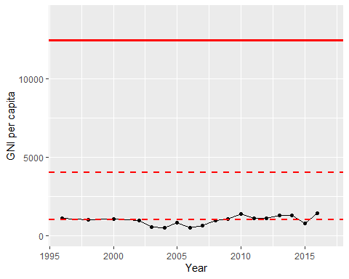

GNI Per Capita Trend